**DAY 2**

**Part 1: Azure infrastructure Configuration**

**Task 1.1 : 1 Create Resource groups based on different project environments(eg:Development,Testing,Production).Explain the organizational benefits of using Resource Groups.**

1.open Microsoft Azure goto home and then select RESOURCE GROUPS

2. select Resource Group and open it

3. Resource group page opens and then give name to Resource group and click Review + create

4. in Resource group name give name as Development and region US east US and click Review + create

5.after Review and create validation pass message will appear and select create and enter

6. . in Resource group name give name as Testing and region US east US and click Review + create

7. in Resource group name give name as Production and region US east US and click Review + create

8.After creating all Resource groups, the list of resource groups will appear

**Organizational Benefits of using Resource Groups**

Azure Resource Groups are a fundamental organizational structure in Microsoft Azure, offering several key advantages. They provide efficient management of Azure resources by enabling users to group related resources together. This simplifies deployment, monitoring, and resource lifecycle management. Additionally, Resource Groups facilitate cost control and resource access control, allowing for precise management of Azure assets. They improve the overall organization and visibility of resources, enhancing operational efficiency and simplifying administrative tasks in the Azure cloud environment. Azure Resource Groups are a fundamental organizational and management construct within Microsoft Azure, designed to help streamline and optimize your cloud infrastructure. They serve as containers that group related Azure resources together, enabling efficient management, governance, and organization of your cloud assets. Alongside Resource Groups, there are several important concepts and related components in Azure that contribute to a holistic understanding of managing your resources effectively.

Creating Virtual Machine

1.Goto home and select create resource and select resource group

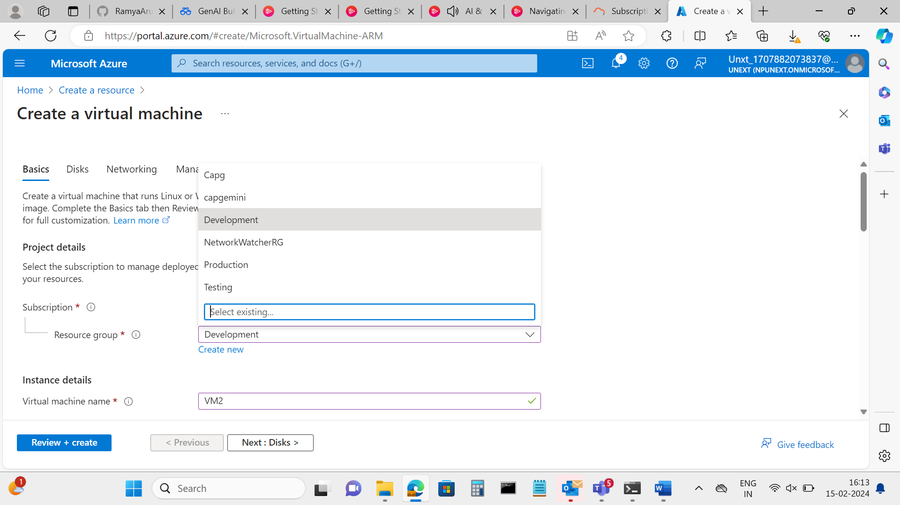

2. Give Virtual Machine name as you wish and select “No infrastructure redundancy required” from availability options

Availabitity zone

Availability set

3. Give username and password

4.Check the checkbox and click Review + create

5.Validation passed message appears and if there is no error click create

6.VM deployment will be in progress

7.Completion message appears

8.click on Go To Resource ,the below page opens select connect and connect

9.Download RDP file

10.select connect

11.give the password and click ok ,virtual machine will be created

